Original Article/ Review Article/ Short Communication/ Case Report/ Book Review
Paper Title (16 Bold)

Author1,^{a,}* Author2,ª Author3,^{b} Author4^{c} (9)

ª Address1 (8, italic)
^{b} Address2
^{c} Address3

*Corresponding author: email@niosh.com.my

Article history  Received xx/xx/xxxx  Accepted (Panel 1) xx/xx/xxxx  Accepted (Panel 2) xx/xx/xxxx | ABSTRACT (11 BOLD) : The abstract should summarize the content of the paper. Try to keep the abstract below 200 words. Do not make references nor display equations in the abstract. The journal will be printed from the same-sized copy prepared by you. Your manuscript should be printed on A4 paper (21.0 cm x 29.7 cm). Leave margins at 2.54 cm at the top & bottom and 1.9 cm at left & right sides of each page.The margins and style described below must be adhered to carefully. This will enable us to keep uniformity in the final printed copies of the Journal. Please keep in mind that the manuscript you prepare will be photographed and printed as it is received. Readability of copy is of paramount importance. (10 Italic)  Keywords (11 Bold) : About five key words in alphabetical order, separated by comma (10 Italic). Please capitalize each word.  All rights reserved.

1.0 INTRODUCTION (11 BOLD)
The introduction of the paper should explain the nature of the problem, previous work, purpose, and the contribution of the paper. The contents of each section may be provided to understand easily about the paper. Clearly state the purpose of the article. Summarize the rationale for the study or observation. Give only strictly pertinent references, and do not review the subject extensively. (Font size 10)

2.0 HEADINGS (11 BOLD)
The first headings should be started with "1.0 INTRODUCTION", appear in upper case, set in bold and aligned flush left. All headings from the Introduction to Conclusion are numbered sequentially using 1.0, 2.0, 3.0, etc. The font size for heading is 11 points bold face. Do not underline any of the headings, or add dashes, colons, etc.

  - Subheadings (10)
The subheading should be stated with “1.1 Subheadings”, lower case letters and aligned flush left. Subheadings are numbered 1.1, 1.2, etc. If a subsection must be further divided, the numbers 1.1.1, 1.1.2, etc. The font size for subheading is 10 points and not bold. Do not underline any of the subheadings, or add dashes, colons, etc.

  - Indentations and Equations (10)
The first paragraph under each heading or subheading should be flush left, and subsequent paragraphs should have a five-space indentation. A colon is inserted before an equation is presented, but there is no punctuation following the equation.
All equations are numbered and referred to in the text solely by a number enclosed in a round bracket (i.e., (3) reads as "equation 3"). Ensure that any miscellaneous numbering system you use in your paper cannot be confused with a reference [4] or an equation (3) designation. For example:

$$RII= \frac{\sum{w}}{AN}=\frac{{5n}_{5}+{4n}_{4}+{3n}_{3}+{2n}_{2}+{1n}_{1}}{5N}$$ | (3)

  - Figures and Tables (10)
To ensure a high-quality product, diagrams and lettering MUST be computer-drafted. Figure captions appear below the figure, are centered below the figure and are in upper and lower case letters (9). When referring to a figure in the body of the text, the abbreviation "Fig." is used. Figures should be numbered in the order they appear in the text.

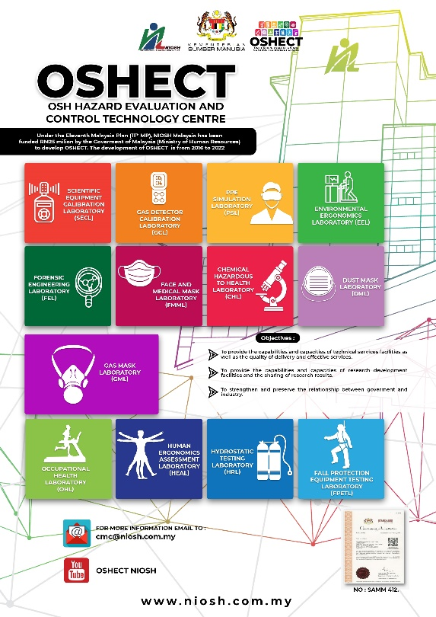
Figure 1: OSHECT Brochure

Table captions appear centered above the table in upper and lower case letters. When referring to a table in the text, no abbreviation is used and "Table" is capitalized. (9). Symbols and abbreviations are defined immediately below the table.

Table 1 Catalytic Alkylation of Resorcinol to 4-tert-butyl Resorcinol and 4,6-di tert-butyl Resorcinol ª
Entry | Catalysts | Conversion / % | Product yield / mmol | Selectivity / % |  | Ratio of Lewis acid to Brönsted acid ^{b}
 |  |  |  | 4-tert butyl resorcinol | 4,6-di tert-butyl resorcinol
1 | MA | 0 | 0 | 0 | 0 | 0
2 | 3%Ga-BEA | 38.0 | 15.6 | 97.4 | 2.6 | 0.5
3 | 8%Ga-BEA | 54.4 | 21.7 | 95.8 | 4.2 | 0.7
4 | 10%Ga-BEA | 59.1 | 23.6 | 100 | 0 | 1.0
5 | 25%Ga-BEA | 32.2 | 12.9 | 100 | 0 | 1.5
6 | H₂SO₄ ^{c} | 6.5 | 2.6 | 96.0 | 4.0 | contain only Brönsted acid
7 | MA + H₂SO₄ ^{d} | 6.0 | 2.4 | 96.0 | 4.0 | 1.0

ª All reactions were carried out at 80 °C for 8 h with resorcinol (40 mmol), MTBE (60 mmol) and catalyst (0.2 g) with vigorous stirring.
^{b} The ratio of Lewis acid to Brönsted acid is calculated by using the peak area of peaks at wavenumber of 1540 cm⁻¹ and 1450 cm⁻¹ for Brönsted and Lewis acids, respectively (see Fig. 1).
^{c} The amount of H₂SO₄ is 25 mol.
^{d} The MA in a solution containing H₂SO₄. The amount of MA and H₂SO₄ are similar as entries 1 and 6, respectively.

3.0 METHOD (11 BOLD)
Method is proposal of new or an overviews of recent technical and methodological developments. Articles should present a new experimental, engineering, scientific or computational method, test or procedure. The method described may either be completely new, or may offer a better version of an existing method.
Method must be proven by its validation, its application to an important research question and results illustrating its performance in comparison to existing approaches. Articles should possess thorough assessments of methodological performance and comprehensive technical descriptions that facilitate immediate application by researchers in the field.

4.0 RESULT (11 BOLD)
Present your result in logical sequence in the text, tables and illustrations. Do not repeat in the text all the data in the tables or illustrations, or both: emphasise or summarise only important observations.

5.0 DISCUSSION (11 BOLD)
Emphasise the new and important aspects of the study and conclusion that follow from them. Do not repeat in detail data given in the Result section. Include in the Discussion the implications of the findings and their limitations and relate the observations to other relevant studies.

6.0 CONCLUSION (11 BOLD)
A conclusion section must be included and should indicate clearly the advantages, limitations, and possible applications of the paper. Although a conclusion may review the main points of the paper, do not replicate the abstract as the conclusion. A conclusion might elaborate on the importance of the work or suggest applications and extensions.
Link the conclusion with the goals of the study but avoid unqualified statement and conclusion not completely supported by your data. Avoid claiming priority and alluding to work that has not been completed. Please state new hypothesis when warranted, and clearly label them as such. Recommendation, when appropriate, may be included.

ACKNOWLEDGEMENT (11 BOLD)
(This heading should be aligned center and is not assigned a number.)
An acknowledgement section may be presented after the conclusion, if desired. Acknowledge grants awarded in aid of the study (state the number of the grant, name and location of the institution or organisation), as well as persons who have contributed significantly to the study. Authors are responsible for obtaining written permission from everyone acknowledged by name, as readers may infer their endorsement of the data. (9)

REFERENCES (11 BOLD)
(This heading is not assigned a number.)

All references must be formatted in accordance with the Publication Manual of the American Psychological Association (APA), Latest Edition.
For example:
Book:
Strunk, W., Jr., & White, E. B. (1979). The guide to everything and then some more stuff. New York, NY: Macmillan.
Gregory, G., & Parry, T. (2006). Designing brain-compatible learning (3rd ed.). Thousand Oaks, CA: Corwin.

Chapter of a Book:
Bergquist, J. M. (1992). German Americans. In J. D. Buenker & L. A. Ratner (Eds.), Multiculturalism in the United States: A comparative guide to acculturation and ethnicity (pp. 53-76). New York, NY: Greenwood.

Journal Article with DOI:
Paivio, A. (1975). Perceptual comparisons through the mind's eye. Memory & Cognition, 3, 635-647. doi:10.1037/0278-6133.24.2.225

Journal Article without DOI (when DOI is not available):
Becker, L. J., & Seligman, C. (1981). Welcome to the energy crisis. Journal of Social Issues, 37(2), 1-7.
Hamfi, A. G. (1981). The funny nature of dogs. E-journal of Applied Psychology, 2(2), 38 -48. Retrieved from http://ojs.lib.swin.edu.au/index.php/fdo

Online Newspaper Articles:
Becker, E. (2001, August 27). Prairie farmers reap conservation's rewards. The New York Times. Retrieved from http://www.nytimes.com

Encyclopedia Articles:
Brislin, R. W. (1984). Cross-cultural psychology. In R. J. Corsini (Ed.), Encyclopedia of psychology (Vol. 1, pp. 319-327). New York, NY: Wiley.
Developmental genetics. (2005). In Cambridge encyclopedia of child development. Retrieved from http://0-www.credoreference.com.library.muhlenberg.edu:80/entry/cupchilddev/developmental_genetics

Technical and Research Reports (often with corporate authors)
Hershey Foods Corporation. (2001, March 15). 2001 Annual Report. Retrieved from http://www.hersheysannualreport.com/2000/index.htm

Book Reviews:
Dent-Read, C., & Zukow-Goldring, P. (2001). Is modeling knowing? [Review of the book Models of cognitive development, by K. Richardson]. American Journal of Psychology, 114, 126-133.
NOTE: For articles that have a DOI, see Journal Article with DOI example.

Data Sets:
Simmons Market Research Bureau. (2000). Simmons national consumer survey [Data file]. New York, NY: Author.

Blog post:
Lincoln, D. S. (2009, January 23). The likeness and sameness of the ones in the middle. [Web log post]. Retrieved from http://www.blogspace.com/lincolnworld/2009/1/23.php

Website with no author or date of publication:
Census data revisited. (n.d.). Retrieved March 9, 2009, from Harvard, Psychology of Population website, http://harvard.edu/data/index.php

Do not include retrieval dates unless the source material may change over time. If no DOI has been assigned to the content, provide the homepage URL.

Reprint from another Source:
- Citation in the text:
(Newton, 1998/1999).
- Reference List Citation:
Newton, W. (1999). Return to Mars. In C. Mari (Ed.), Space Exploration (pp. 32- 41). New York, NY: H.W. Wilson. (Reprinted from National Geographic, pp. 2-26, August 1998).
- In this example of a reprinted book review, the author of the book is named first, followed by the editor of the reprinting source, then the reviewer. In your parenthetical citation, it is necessary to name the author of the book, while the reviewer is named to distinguish from other reviews of this book.

